Homework #6
(Module 6: Volt-VAR Optimization)

Question 1: The ANSI C84.1 standard defines the voltage ranges for end-use customers during normal and emergency operation of the distribution system. When in the emergency operating region, what is the equivalent tolerance (in percent)?
- +/- 5.0%
- + 10.4%/-5.2%
- +7.2%/-5.3%
- +5.8%/-10.8%
Question 2: What is a key advantage to using a typical Volt-VAR optimization scheme over a standalone regulator?
- Monitoring of multiple end-of-line measurement points
- Faster operation of the tap changes
- Less voltage drop
- Reduction in line impedance
Question 3: : For a typical Volt-VAR control scheme as discussed in the module, what would b expected benefits?
- Real power was significantly reduced and reactive power was decreased slightly
- Power factor decreased
- Reactive power consumption decreased significantly with a noticeable reap power decrease
- All of the above

Question 4: Use the simple 4-node System A. Assume regulators have 100-Volt tap positions, 4,700 Volts is the desired level, 4,500 Volts is the minimum system limit, and 5,200 Volts is the maximum system limit. Does the system require any regulatory changes to be at the proper operating point?
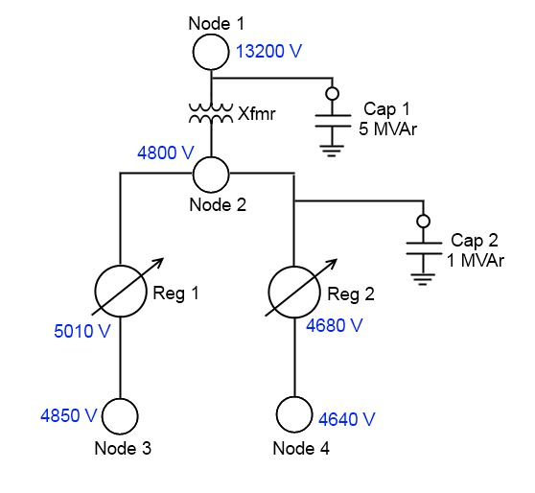
Sample System A with Volt-VAR Control Scheme

- Reg 1 is set too low and requires changes.
- Reg 1 is set too high and requires changes.
- Reg 2 is set too low and requires changes.
- The system does not require any changes.
Question 5: Use the simple 4-node System A. Assume regulators have 100-Volt tap positions, 4700 Volts is the desired level, 4500 Volts is the minimum system limit, and 5200 Volts is the maximum system limit. Assume an ideal power system (no additional losses and consistent voltage drops). Continuing Question 4, what would the expected result of a Volt-VAR control action be?
- Reg 2 would tap up to give a voltage at Node 3 of 4670 Volts.
- Reg 1 would tap down to give a voltage at Node 3 of 4750 Volts.
- Reg 2 would tap down to give a voltage at Node 3 of 4700 Volts.
- The system does not require any changes.

Question 6: Use the simple 4-node System A. Assume regulators have 100-Volt tap positions, 5000 Volts is the desired level, 4600 Volts is the minimum system limit, and 5100 Volts is the maximum system limit. Which situation represents the most accurate statement about Reg 1?
- Reg 1 is set too low and will tap up.
- Reg 1 is set too low, but is unable to tap up.
- Reg 1 is set too high and needs to tap down.
- No change is needed for Reg 1.
Question 7: Use the simple 4-node System A. What effect could switching Cap 1 have on the entire system?
- It could lower the voltage and cause violations.
- It could raise the voltage and require regulator actions.
- It could cause Xfmr to short circuit.
- It could raise the voltage at only Node 1.

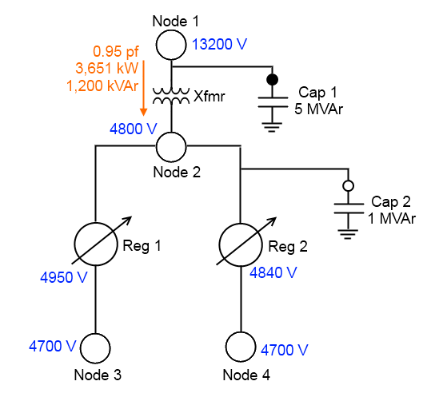
Sample System B with Volt-VAR Control Scheme
Question 8: Use the simple 4-node System B. Assume regulators have 100-Volt tap positions, 4700 Volts is the desired level, 4500 Volts is the minimum system limit, and 4900 Volts is the maximum system limit. Assume d_{min} = 0.2 and d_{max} = 0.8. Assume all capacitors are controlled by the Volt-VAr controller, regardless of location. Given the conditions in the system, what would the Volt-VAr controller do for the state of Cap 1 (currently active)?
- Cap 1 will remain on because the reactive power is above the proper threshold
- Cap 1 will switch off because the reactive power is below the proper threshold
- Cap 1 will remain on because a regulator action is needed first
- Cap 1 will switch off because the power factor is too high
Question 9: Use the simple 4-node System B. Assume regulators have 100-Volt tap positions, 4700 Volts is the desired level, 4500 Volts is the minimum system limit, and 4900 Volts is the maximum system limit. Assume d_{min} = 0.2 and d_{max} = 0.8. Assume all capacitors are controlled by the Volt-VAr controller, regardless of location. Given the current conditions of the system, what is the expected action of Cap 2?
- Cap 2 will remain off because the reactive power is below the proper switching threshold
- Cap 2 will switch on because the reactive power is above the proper switching threshold
- Cap 2 will switch on because the reactive power is below the proper switching threshold
- Cap 2 will remain off because it is smaller than Cap 1
Question 10: Use the simple 4-node System B. Assume regulators have 100-Volt tap positions, 4700 Volts is the desired level, 4500 Volts is the minimum system limit, and 4900 Volts is the maximum system limit. Assume d_{min} = 0.2 and d_{max} = 0.8. Assume all capacitors are controlled by the Volt-VAr controller, regardless of location. The reactive power through Xfmr is assumed to be inductive in nature. Given the current conditions of the system and assuming only reactive power would be adjusted by inserting Cap 2, what is the expected power factor magnitude when the operation is complete?
- 0.95
- 0.97
- 1.00
- 1.05

